Implementation of a Proactive Defense System
Using Honeypots & FortiGate NGFW — GNS3 Project
Student | Abdelrahman Abu Laila
Major | Cybersecurity
Supervisor | Dr. Jehad Hamamreh
Firewall | FortiGate VM64-KVM 7.0.9
Honeypot | Cowrie SSH/Telnet Honeypot
Simulation | GNS3 Network Emulator
Date | April 2026

1. Introduction
This project implements a proactive defense system inside GNS3. The idea is simple: instead of just blocking attackers, we attract them into a fake environment (a honeypot), watch everything they do, and keep the real production server completely hidden.
The FortiGate NGFW handles traffic redirection — any SSH connection attempt on the external IP is silently forwarded to the Cowrie honeypot. The attacker never touches the real server. All their actions are logged and displayed on a live monitoring dashboard.

1.1 Project Goals
- Redirect all external SSH attacks to the Cowrie honeypot using FortiGate VIP
- Keep the real production Ubuntu server fully isolated from WAN traffic
- Log every attacker action: login attempts, commands, file downloads
- Display live attack data through a custom web dashboard
- Simulate a realistic attack scenario using Kali Linux tools (Nmap, Hydra)

2. Tools Used
Tool | Version | Role
GNS3 | Latest | Network simulation platform
FortiGate VM | 7.0.9 (KVM) | NGFW — firewall, NAT, VIP, policies
Cowrie | Latest (GitHub) | SSH/Telnet honeypot — logs all attacker actions
Kali Linux | 2025.4 | Attacker machine — Nmap, Hydra, SSH
Ubuntu Cloud | 22.04 | Honeypot host + production server
Python Flask | 3.x | Real-time monitoring dashboard

3. Network Topology
The network is divided into three zones. All traffic between zones passes through the FortiGate firewall.
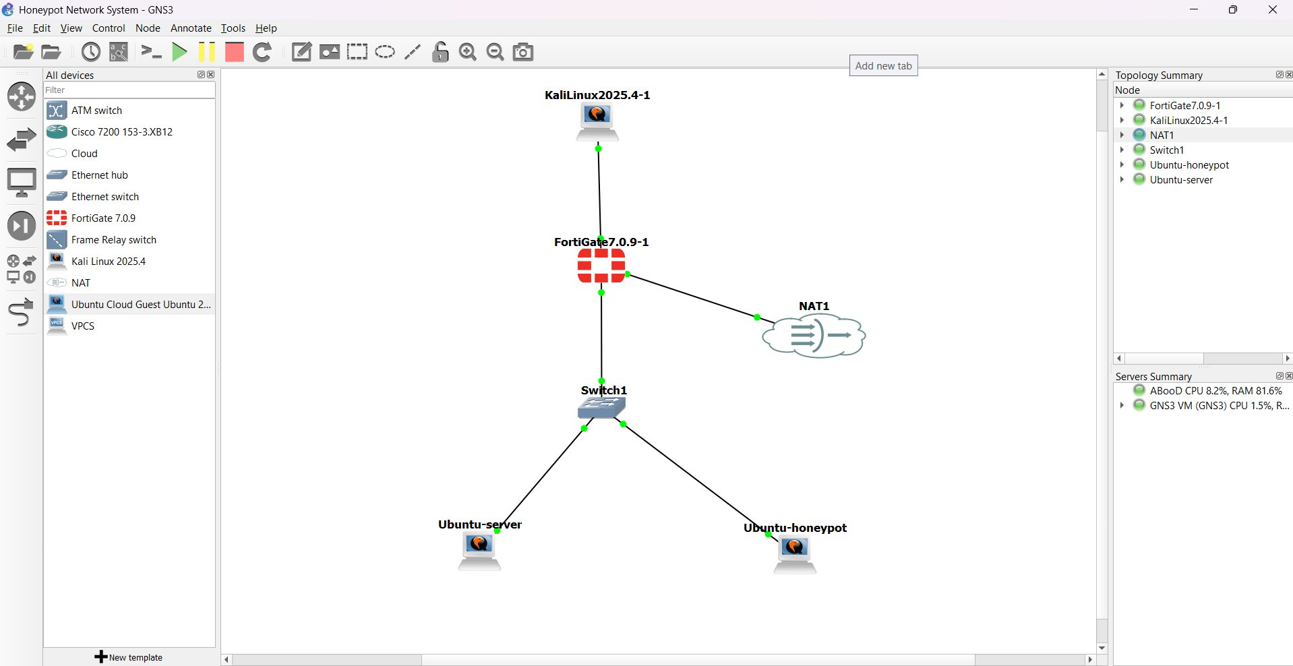
Figure 3.1 — GNS3 topology: Kali (WAN) → FortiGate → Switch → Honeypot & Production Server
Zone | Device | IP Address | Notes
WAN (External) | FortiGate port1 | 192.168.1.1 | Faces the attacker
WAN (External) | Kali Linux | 192.168.1.10 | Simulated attacker
DMZ | Ubuntu Honeypot | 10.0.0.10 | Cowrie listens on port 2222
LAN (Internal) | Ubuntu Production | 172.16.0.10 | Real server — never exposed

4. FortiGate Configuration

4.1 Virtual IP (VIP) — Traffic Redirection
The VIP is the core of the deception. It maps the FortiGate's external port 22 to the honeypot's internal port 2222. The attacker connects to 192.168.1.1:22 thinking it's a real SSH server — FortiGate silently redirects the connection to Cowrie at 10.0.0.10:2222.
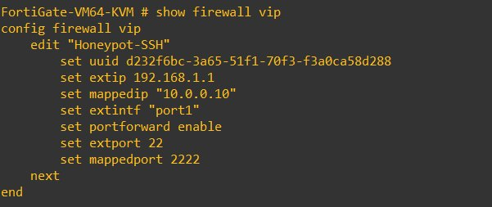
Figure 4.1 — FortiGate VIP: external port 22 → honeypot 10.0.0.10:2222
config firewall vip
edit "Honeypot-SSH"
set extip 192.168.1.1
set mappedip "10.0.0.10"
set extintf "port1"
set portforward enable
set extport 22
set mappedport 2222
next
end

4.2 Firewall Policies
Three policies control all traffic in the network:
- Kali_to_Honeypot / To-Honeypot-VIP — Allows WAN → DMZ (honeypot only)
- Allow_Internet_for_Honeypot — Allows DMZ → Internet (so Cowrie can handle wget commands)
- Block-ALL — Drops everything else, including any WAN → LAN traffic
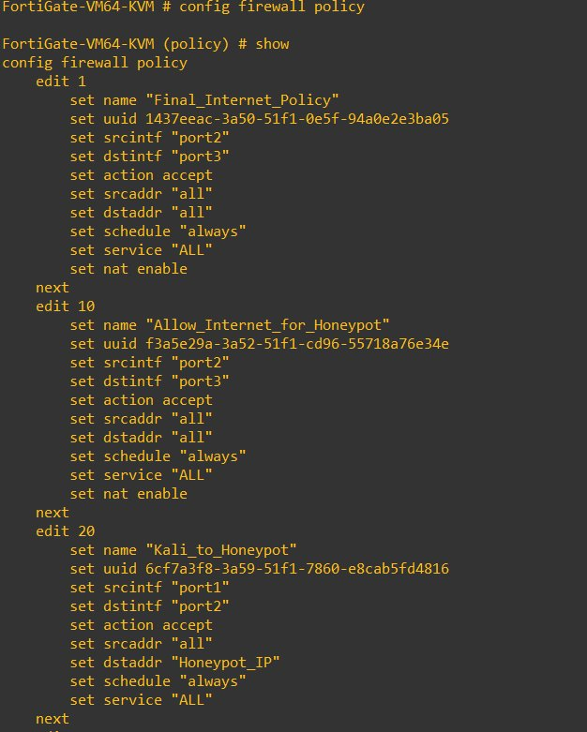
Figure 4.2 — FortiGate firewall policies
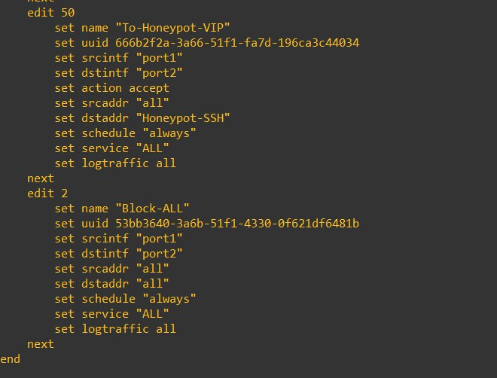
Figure 4.3 — To-Honeypot-VIP and Block-ALL policies

5. Cowrie Honeypot Setup
Cowrie was installed on the Ubuntu server in the DMZ zone. It runs as a non-root user and listens on port 2222. It emulates a full Debian Linux shell — the attacker gets a fake terminal, fake filesystem, and even real internet commands like wget.

5.1 Installation Steps
# Install dependencies
sudo apt-get install -y git python3 python3-virtualenv libssl-dev libffi-dev build-essential

# Create dedicated user
sudo adduser --disabled-password cowrie && sudo su - cowrie

# Clone and set up virtual environment
git clone http://github.com/cowrie/cowrie && cd cowrie
virtualenv --python=python3 cowrie-env
source cowrie-env/bin/activate
pip install --upgrade pip && pip install -r requirements.txt

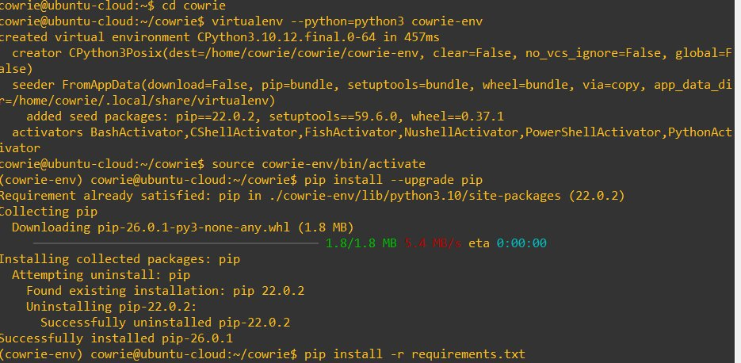
Figure 5.1 — Setting up the Python virtual environment for Cowrie

5.2 Key Configuration (cowrie.cfg)
- listen_port = 2222 (Cowrie listens here; FortiGate VIP redirects port 22 to it)
- hostname = svr04 (fake hostname the attacker sees after login)
- backend = shell (full interactive shell emulation)

5.3 Accepting Weak Passwords (userdb.txt)
Cowrie is configured to accept common passwords so attackers can log in and we can monitor them:
root:x:* # accept any password for root
root:x:password
root:x:123456
root:x:12345

5.4 Starting Cowrie
bin/cowrie start
bin/cowrie status

Figure 5.2 — Cowrie running (PID: 4413)

6. Attack Simulation
The full attack was performed from the Kali Linux machine (192.168.1.10) targeting the FortiGate WAN IP (192.168.1.1). The simulation covers four phases: connectivity check, port scanning, brute-force, and post-exploitation.

6.1 Phase 1 — Connectivity Check (Ping)
The attacker first confirms the target is reachable.
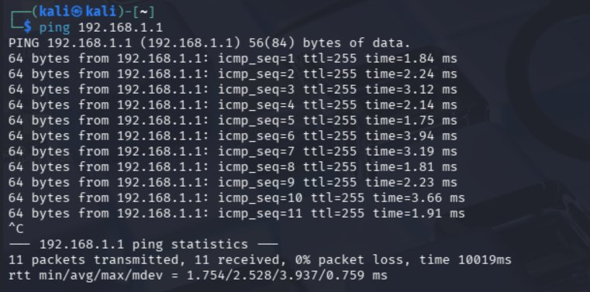
Figure 6.1 — Ping to FortiGate WAN IP 192.168.1.1 — 0% packet loss
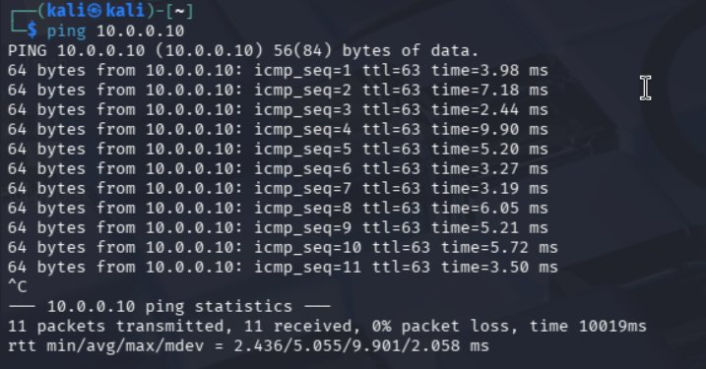
Figure 6.2 — Ping to 10.0.0.10 — TTL=63 confirms traffic passes through the firewall

6.2 Phase 2 — Port Scanning (Nmap)
The attacker uses Nmap to find open ports and identify services:
nmap -sV 192.168.1.1 -oN nmap_report.txt

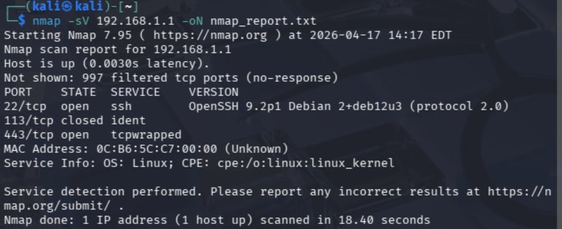
Figure 6.3 — Nmap result: port 22 open, showing OpenSSH 9.2p1 (actually Cowrie's emulation)
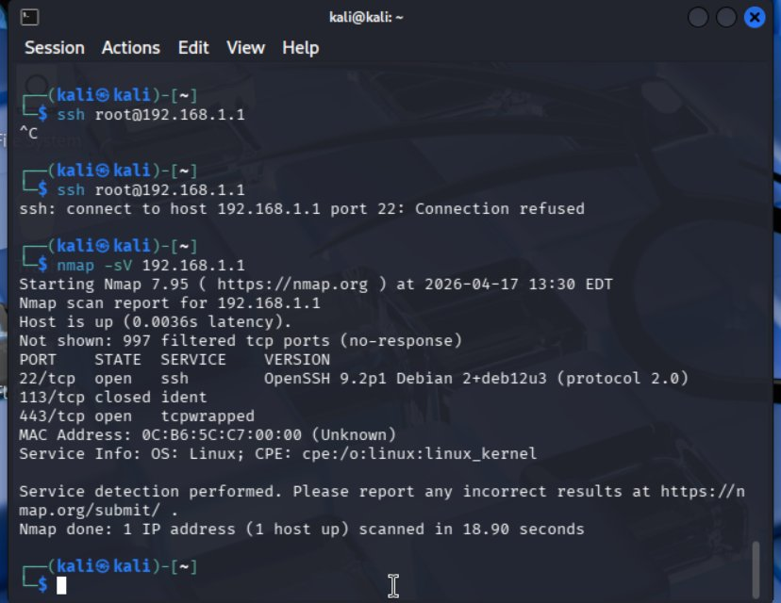
Figure 6.4 — Earlier scan showing port 22 initially refused, then open after VIP was configured
Nmap sees port 22 as open with "OpenSSH 9.2p1 Debian" — this is Cowrie's fake banner. The attacker has no indication this is a honeypot.

6.3 Phase 3 — Brute-Force Attack (Hydra)
Using the rockyou.txt wordlist with 14 million passwords, the attacker runs a brute-force attack:
hydra -l root -P /usr/share/wordlists/rockyou.txt ssh://192.168.1.1 -t 4

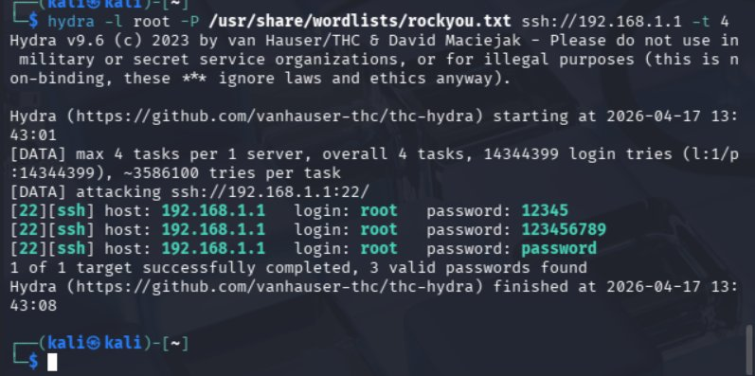
Figure 6.5 — Hydra finds 3 valid credentials: 12345, 123456789, password
Hydra reports success because Cowrie is configured to accept those weak passwords. The attacker now has "valid credentials" and thinks the server is compromised.

6.4 Phase 4 — Manual SSH Login & Post-Exploitation
The attacker logs in manually and starts exploring the system:
ssh root@192.168.1.1
# password: password
root@svr04:~# whoami
root@svr04:~# ls -la
root@svr04:~# wget http://google.com

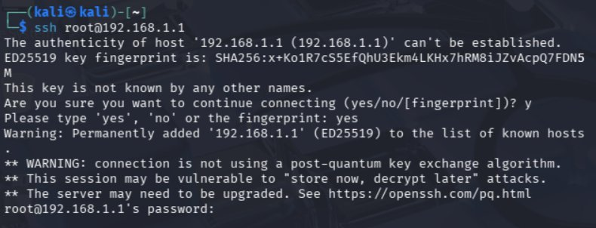
Figure 6.6 — Attacker connects to FortiGate IP — silently lands inside Cowrie
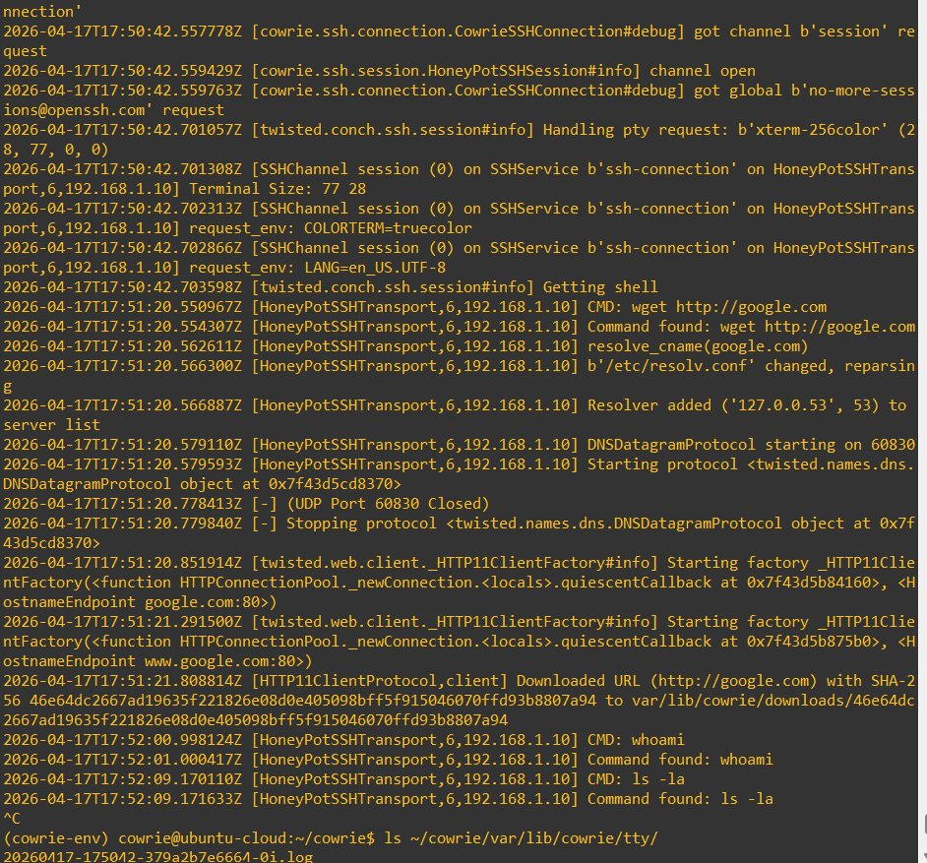
Figure 6.7 — Attacker runs wget, whoami, ls inside the fake shell — all logged by Cowrie
The wget command actually works — Cowrie uses the FortiGate outbound NAT policy to fetch the file for real, making the deception even more convincing. The downloaded file is saved in Cowrie's sandbox, not a real system.

7. Cowrie Logs
Cowrie stores structured JSON logs for every event. During the brute-force attack, every login attempt from 192.168.1.10 was recorded with timestamp, username, and password. During the manual session, every command was logged.
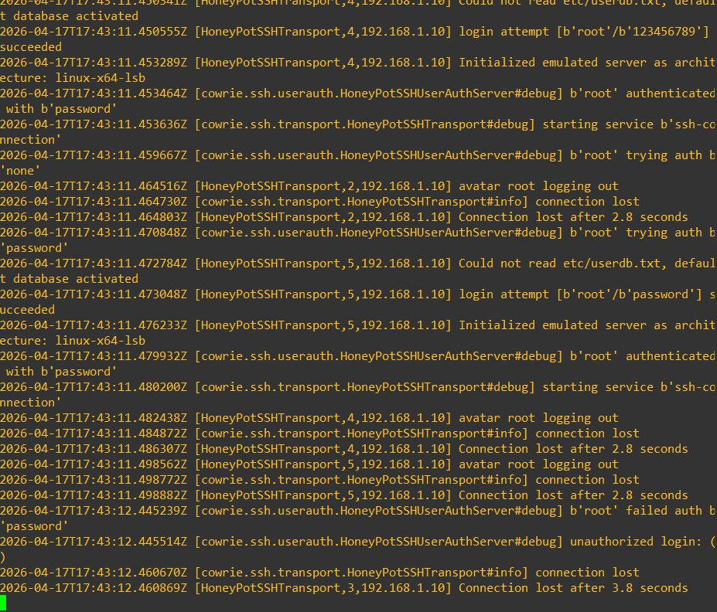
Figure 7.1 — Cowrie logs during brute-force: login successes and failures from 192.168.1.10
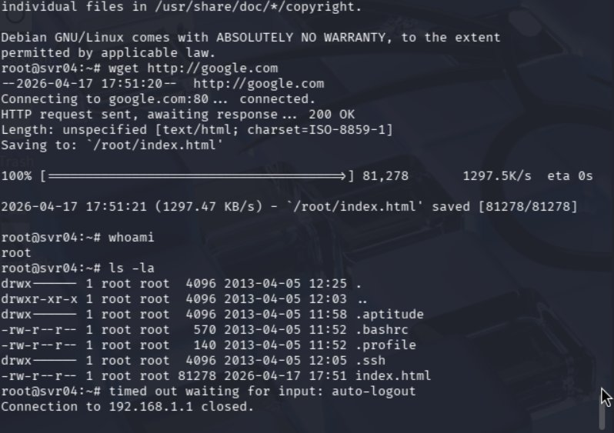
Figure 7.2 — Cowrie session log: wget google.com tracked with DNS resolution and file hash
Key event types captured:
- cowrie.login.success / cowrie.login.failed — brute-force tracking
- cowrie.command.input — every command the attacker typed
- cowrie.session.connect / closed — session duration and attacker IP
- TTY recordings saved to var/lib/cowrie/tty/ — full session replay possible

8. Live Monitoring Dashboard
A Python Flask web app was built on the honeypot machine to parse Cowrie's JSON logs and display them live. It runs on http://10.0.0.10:5000 and shows every attack event in a table with timestamp, attacker IP, and event type.
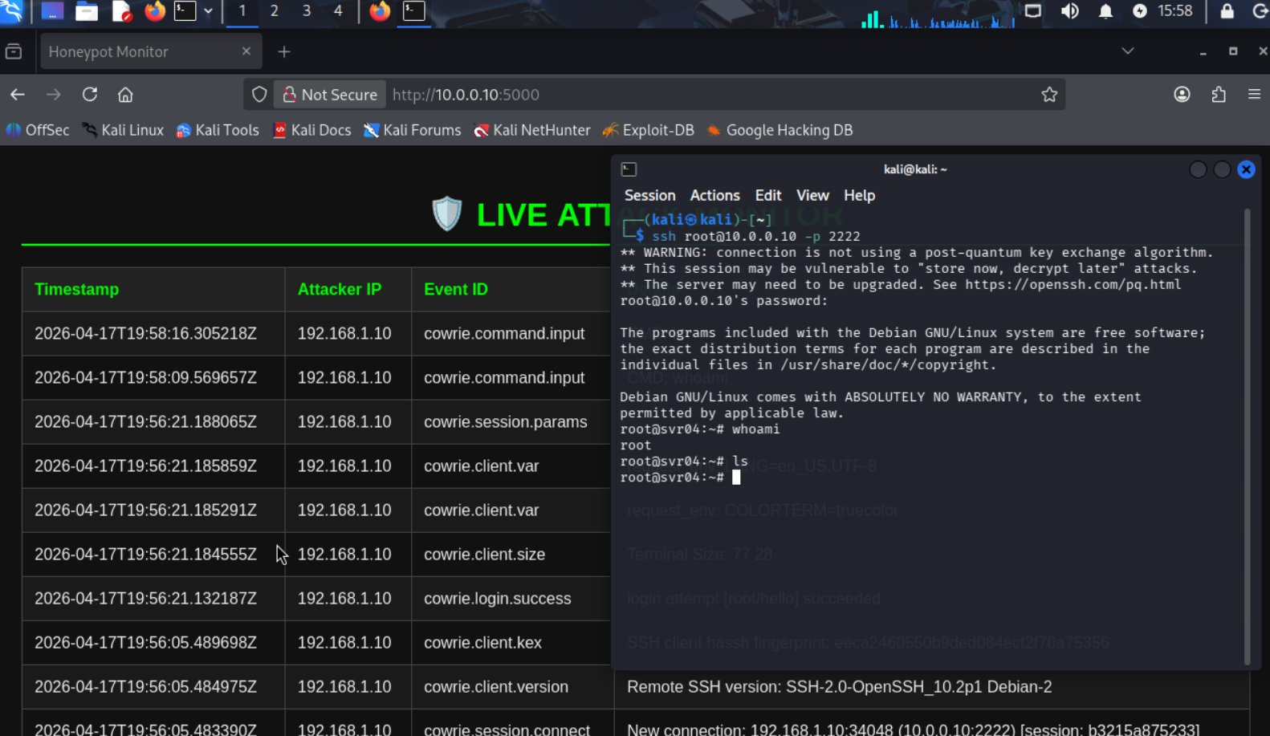
Figure 8.1 — Live dashboard showing attack events alongside the attacker's terminal session
The dashboard shows events like cowrie.command.input, cowrie.login.success, cowrie.session.params, and cowrie.client.version in real time. This gives a full picture of what the attacker is doing without needing to read raw log files.

9. Results and Conclusion

9.1 What Was Achieved
Item | Result
FortiGate VIP (port 22 → 2222) | Working — attacker redirected transparently to Cowrie
Cowrie Honeypot | Running on 10.0.0.10:2222 — accepts connections and logs all actions
Brute-Force Capture (Hydra) | 3 valid passwords found by attacker — all logged by Cowrie
Manual SSH Session | Full session logged including wget, whoami, ls -la
Production Server | Zero traffic reached it — fully protected behind firewall
Monitoring Dashboard | Live events at http://10.0.0.10:5000 — all attack data visible
TTY Recording | Full attacker session replayable from var/lib/cowrie/tty/

9.2 Conclusion
The project successfully deployed a honeypot-based defense system in GNS3. The FortiGate VIP transparently redirected all attacker SSH traffic to Cowrie — the attacker ran commands, downloaded files, and explored the fake filesystem, fully believing they had compromised a real server.
Throughout all attack phases (ping, Nmap, Hydra, manual SSH), the production server received zero traffic. The firewall's Block-ALL policy guaranteed that. Every attacker action was captured in Cowrie's structured logs and displayed on the live dashboard.
This architecture — FortiGate NGFW + Cowrie + real-time dashboard — provides both strong network protection and active threat intelligence collection, which is more valuable than a simple firewall block alone.

